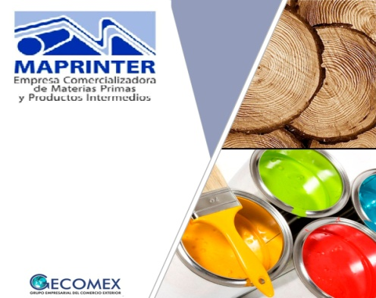
WHO IS MAPRINTER?
Commercial Company of Raw Materials and Intermediate Products. MAPRINTER is a member of the GECOMEX Foreign Trade Business Group.
We constantly work in to satisfy the needs of raw materials and intermediate products to the domestic market, providing a commercial service of excellence backed by more than 50 years of experience in the activity and high professionalism of ours workers, achieving high levels of efficiency in management. We import, export and commercialize raw materials and intermediate products as a wholesale agent. We also provide all services associated with the commercial activity.
IN WHICH KIND OF PRODUCTS, WE ARE IN CHARGE?
Wood, Resins, Paper and Cardboard, Paints, Glass, Flexible Containers
The main destinations of our products are:
Furniture production
Construction sector
Polygraphic industries
Tobacco Sector
An others
Giving you an idea of our products we are providing you the more important in each group:
Paper:
• News Paper
• Bond Paper
• Safety Bond Paper
• Coated paper
• Plasterboard
• Bristol Card
• Hilo Cardboard
• Gray Cardboard
• Self-adhesive paper
• Carbonless paper
• Kraft paper
• Tissue Paper
Wood:
• Hard and semi-hard sawn timber, for the manufacture of furniture and articles for the construction such as: doors and windows.
• Pine, for the manufacture of furniture and for the construction use.
• Agglomerated boards, MDF
• Plywood.
Industrial paints:
• Automotive paints.
• Paints for wood.
• Varnishes.
• Enamels.
• Food grade paints.
• Anti - caloric paints.
• Marine paints.
• Paints for transit.
• Engine paints.
• Painting for aviation.
Plastic resins:
• High and low density polyethylene. (PE)
• Polystyrene. (PS)
• Polypropylenes. (PP)
• Polyvinyl chloride (PVC)
We also are in charge of some of the specific raw materials used by the following industries:
The tobacco industry: papers and woods specific to this industry.
The Cuban factory for the production of sanitary pads such as: pulp cellulose, paper No Woven, Hot Melt Glue, siliconized paper tape, polyethylene film, super absorbent, polyethylene bags.
The Cuban factory for the production of matches: kraft paper, billiard table cloth, pearly wax and block wax: paraffin wax, pearly wax, industrial felt, cardboard for matchboxes, wooden sticks, kraft paper, wisted wick for candles.
YOU COULD CONTACT US:
Address: 23 Avenue. Number 55, second floor, Plaza de la Revolución, Havana. Cuba. (CP-10400)
Telephone numbers: (+53) 7838 06 45, (+53) 7836 07 11 to 17 Ext. 108
CONTACT PEOPLE:
María del Carmen Corvo Digna María Montalvo
Directoral General MAPRINTER Directora de Desarrollo MAPRINTER
mcarmen@maprinter.cu digna@maprinter.cu

